Workflow Specification
for
Hobbs Of Reading Dry Cleaning & Laundrette

By Gurvinder Kaur

1 Revision History 3
2 Index page 5
3 Price list page 6
4 Registration page 7
4.1 Registration – non-business customer 7
4.2 Registration – business customer 8
5 Login page 9
5.1 Login – login screen 9
5.2 Login – confirmation 10
6 Order page 11
6.1 Order page – when the customer is not logged in 11
6.2 Order page – when the customer is logged in 12
7 Payment 14
7.1 Payment – making payment through PayPal 14
7.2 Payment – payment confirmation 15
8 Contact us page 16
9 My account page 17
10 Order history page 18
11 Staff panel page 19
12 Add item page 20
13 Remove item page 21
14 View pending orders page 22
14.1 Non-business customers 22
14.2 Business customers 23
15 View complete orders page 24
15.1 Non-business customers 24
15.2 Business customers 25
16 Create staff account page 26

Revision History
Author | Date | Version | Changes
Gurvinder Kaur |  | 1.0 | Initial screen workflow
Gurvinder Kaur |  | 1.1 | 5.2 Order page – when the customer is logged in  - Amended page – added option to add quantity to items.  - Changed ORDER button to CHECKOUT  6 Basket page  - Added basket page after the order page, and before the payment page.  8 My account page  - Added my account page, customers can view basket and order history from here.  9 Order history page  - Added order history page, customers can view their previous orders from here.
Gurvinder Kaur | 10/12/2013 | 1.2 | 11 Staff panel page  - Added admin panel page, this is shown when a staff member logs in.  12 Add item page  - Added add item page which is linked from the staff panel.  13 Remove item page  - Added remove item page, which is linked from the staff panel.  14 View pending orders page  14.1 Non-business customers  - Added view pending orders page from non-business customers. This is linked from the staff panel.  14.2 Business customers  - Added view pending orders page from business customers. This is linked from the staff panel.  15 View complete orders page  15.1 Non-business customers  - Added view complete orders page from non-business customers. This is linked from the staff panel.  15.2 Business customers  - Added view complete orders page from business customers. This is linked from the staff panel.  16 Create staff account page  - Added create staff account page. Staff can create staff accounts from here; this is linked from the staff panel.

Index page
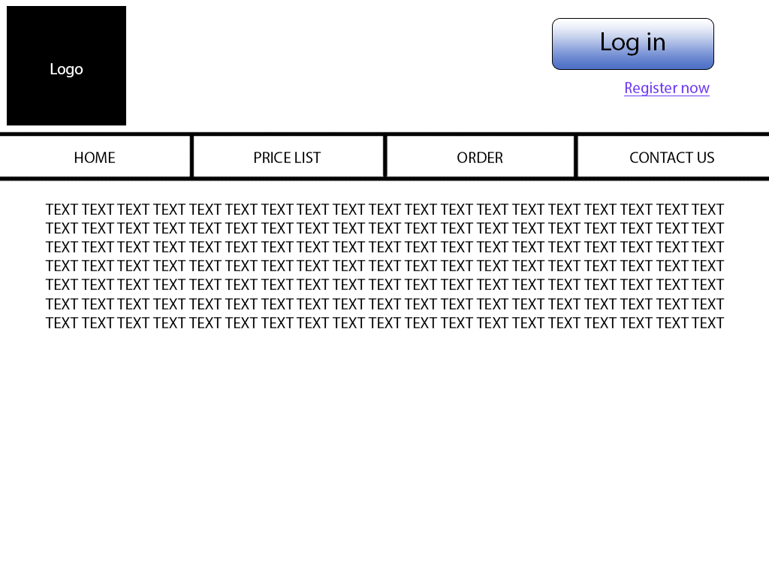
The index page will have a description of the business, and how the website works.

Price list page
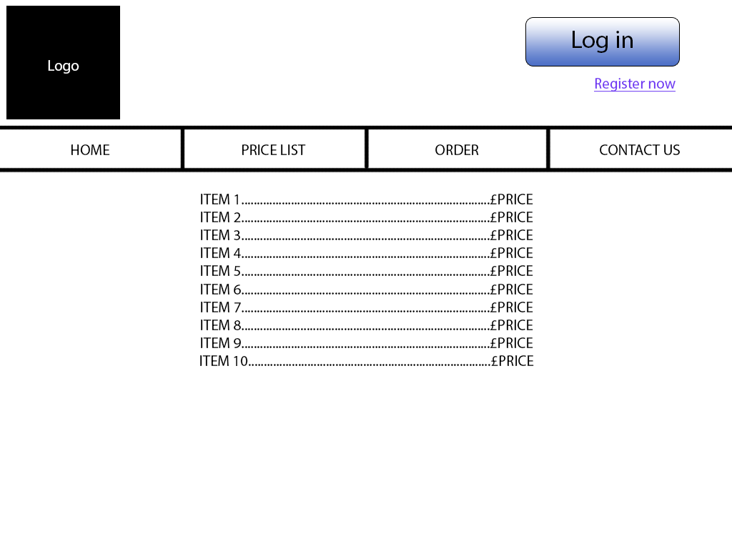
The price list page will include a list of order items along with their prices.

Registration page
There will be two types of customer accounts - business customers, and non-business customers.

Registration – non-business customer

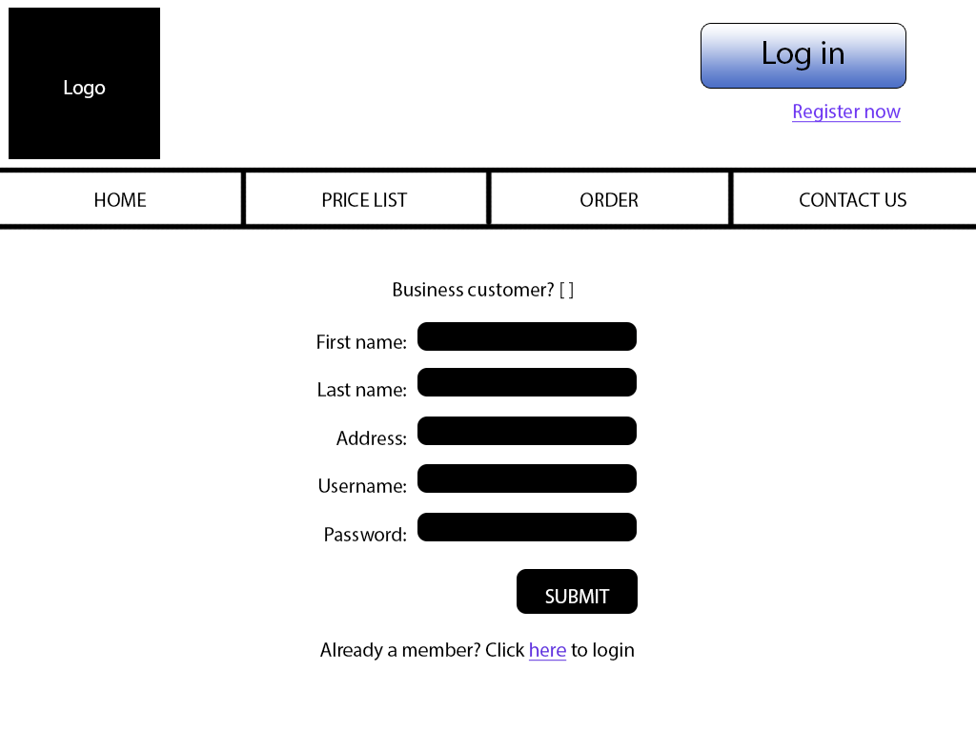
This screen will be shown when non-business customers register.

Registration – business customer

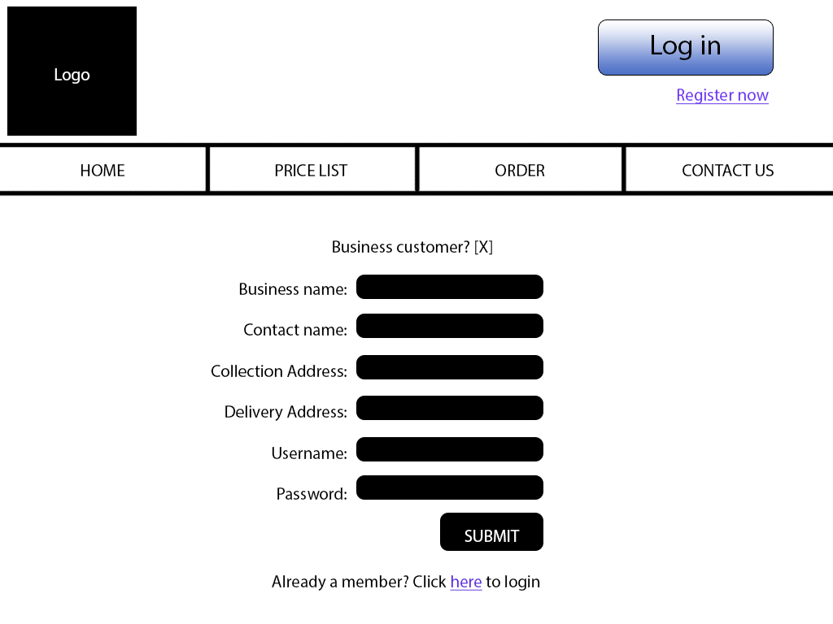
This screen will be shown when business customers register.

Login page
Customers will need to login in order to use services on this website.

Login – login screen
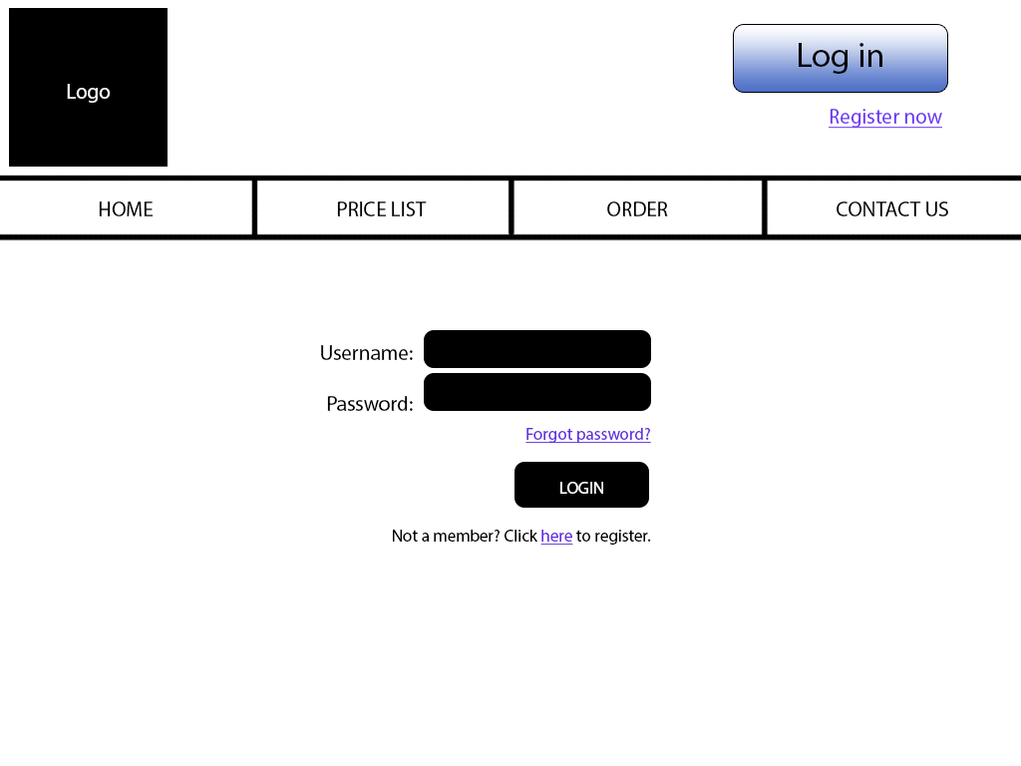
The login screen will be the same for all customers.

Login – confirmation

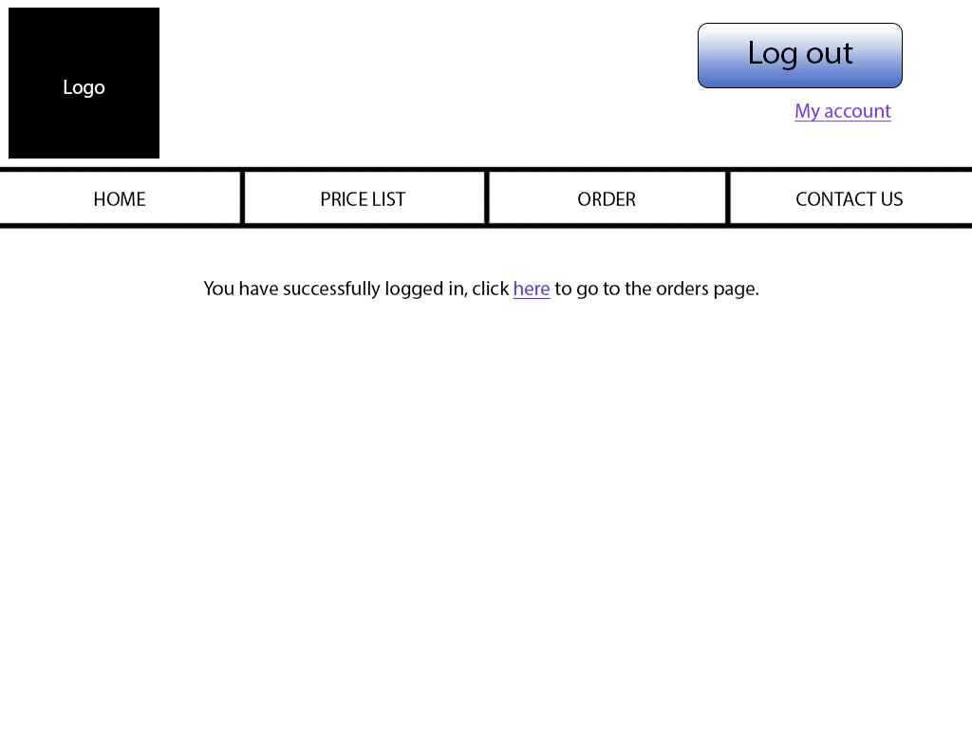
This screen will be displayed when a customer successfully logs in.

Order page
When the user wants to place an order, they click on the order page.

Order page – when the customer is not logged in

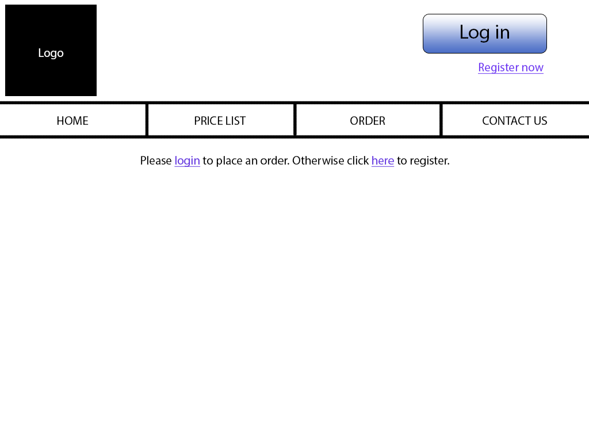
The customer will not be able to place orders until they are logged in. They will be asked to login, or else register.

Order page – when the customer is logged in

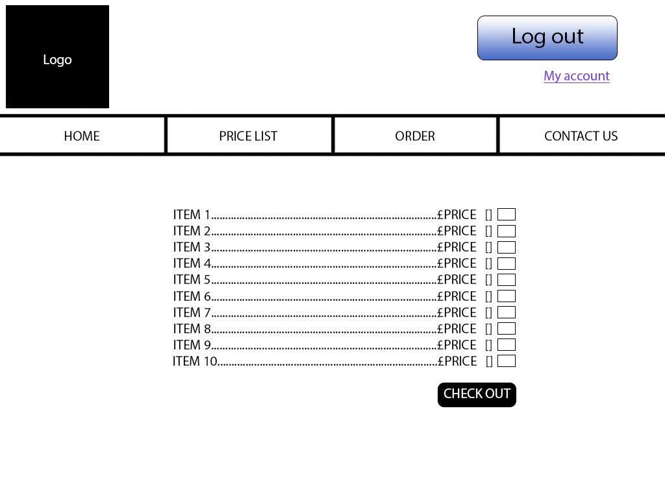
If the customer is logged in and they click on the order page, they will be able to select the services they wish to choose, along with the quantity. They can then click on order to proceed.
Basket page
The user will be taken to the basket when they click on “CHECKOUT” in the order page. The basket will have a summary of their selected items, along with a calculated total.

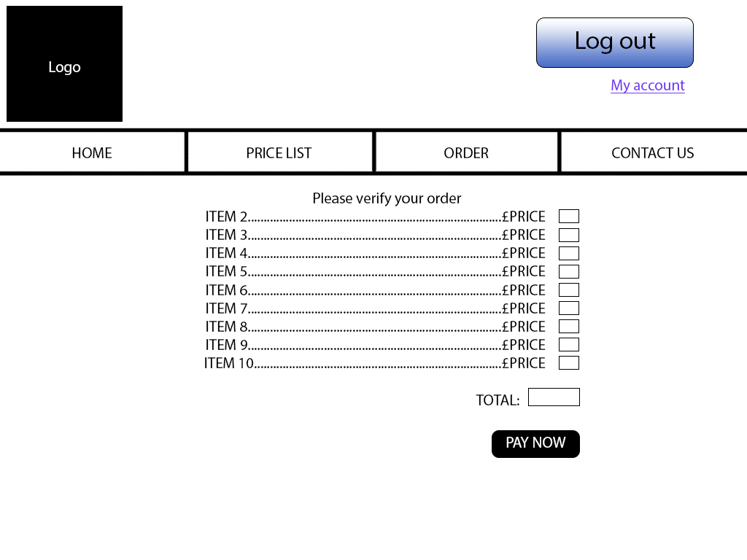
From this screen, the user will be able to click on the “PAY NOW” button to proceed to payment.

Payment

Payment – making payment through PayPal

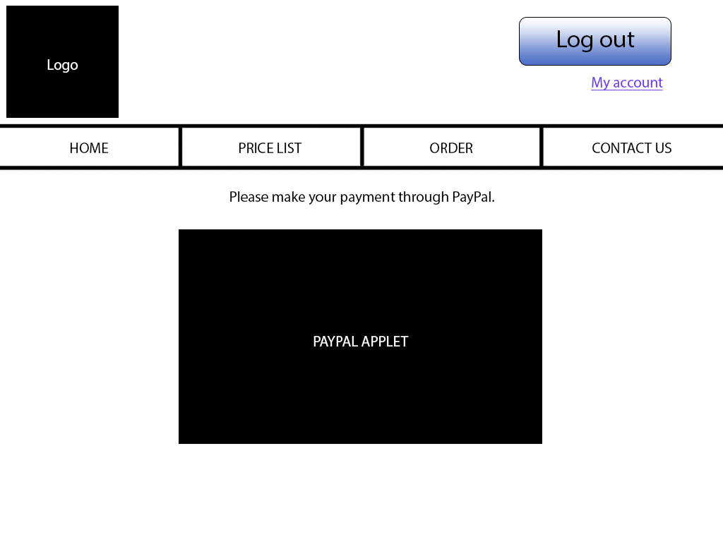
The user is able to make their payment through PayPal.

Payment – payment confirmation

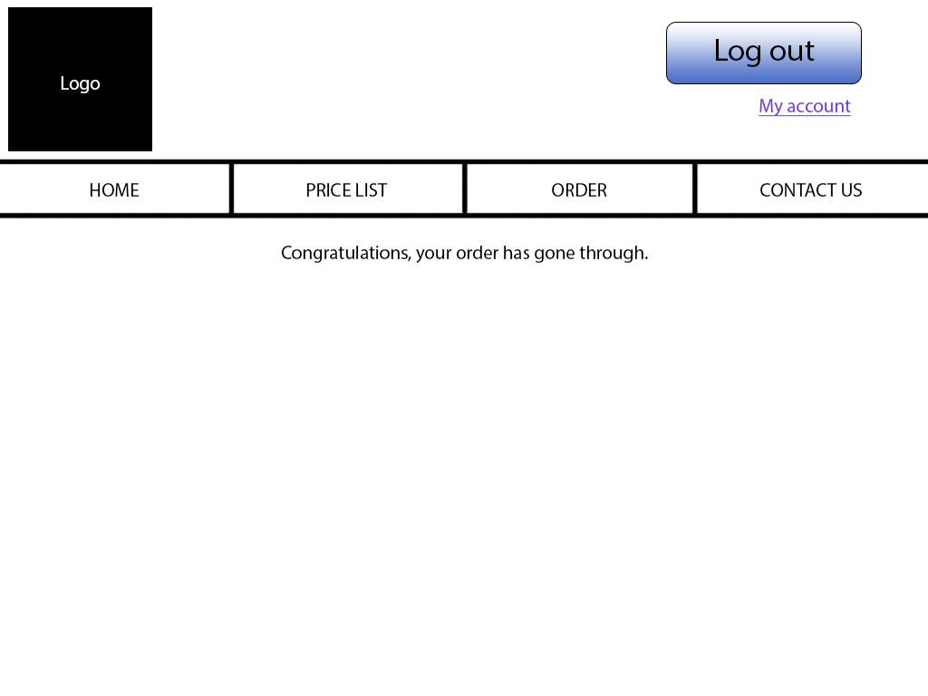
Once the payment has successfully gone through, the user will be notified with a confirmation.

Contact us page
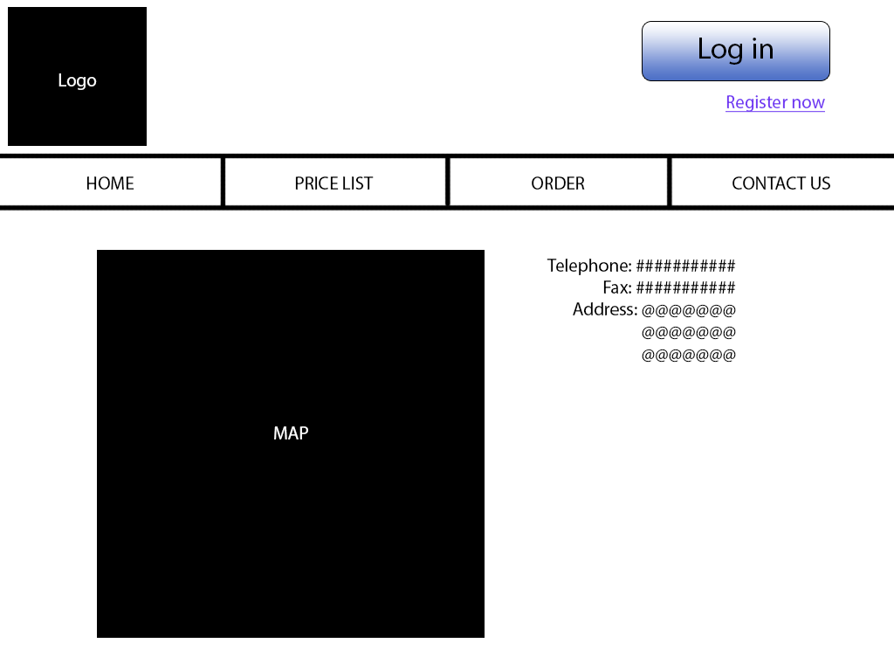
This page will have contact details for the business.

My account page
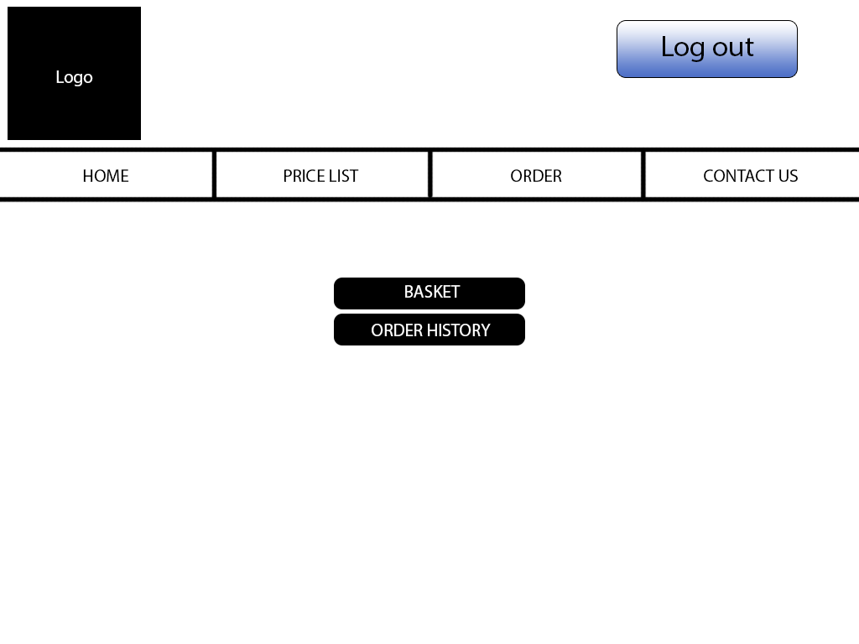
When a customer clicks on my account, they will have an option to view their basket, and their order history.

Order history page
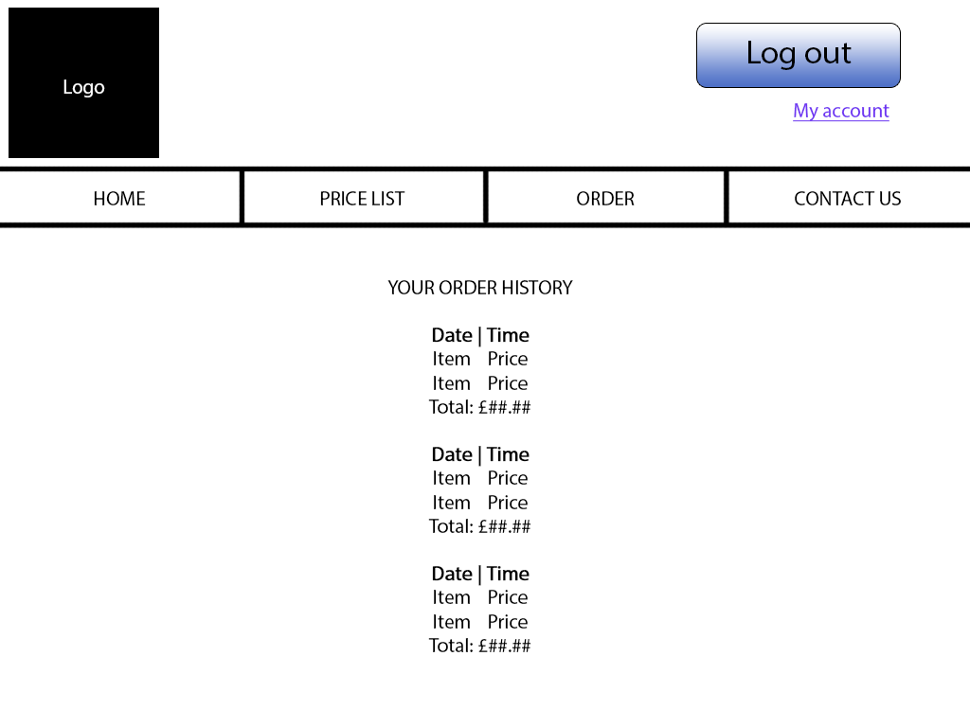
This page can only be accessed through the “My account” page after the user has logged in. Here, the user will see their previous order history.

Staff panel page
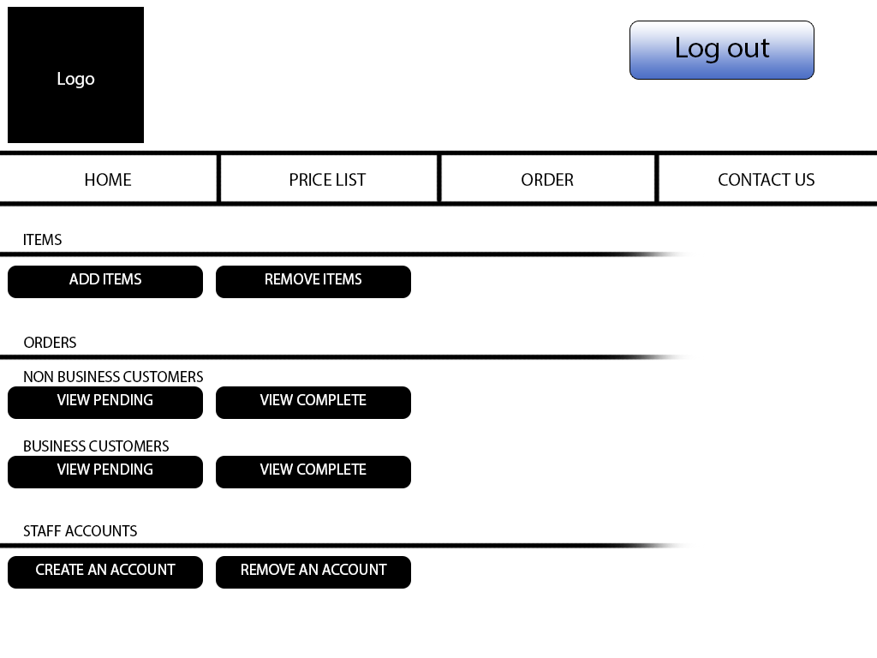
This is what the staff member will see when they log in.
They have options for adding and removing service items.
They have options for viewing pending and complete orders for non-business customers.
They have options for viewing pending and complete orders for business customers.
They have options for creating and removing staff accounts.

Add item page
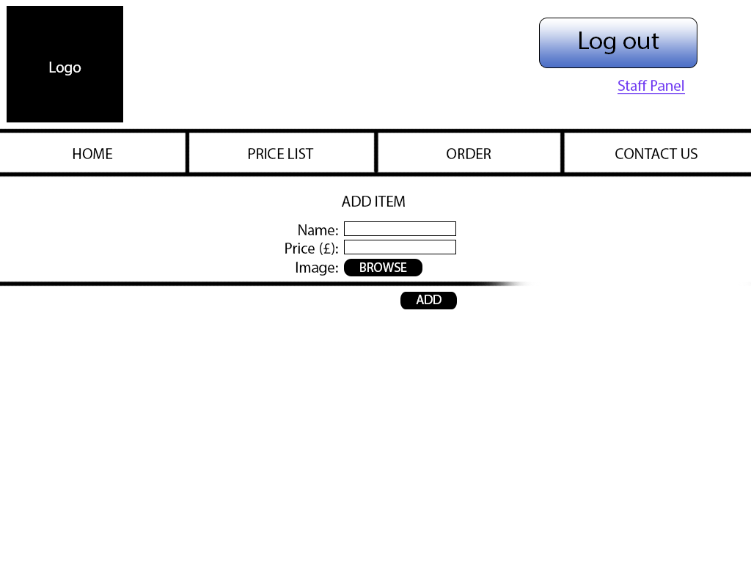
The member of staff can access this page only from the staff panel.
From here they can add additional items by entering a item name and price, and attaching an item image then clicking add.

Remove item page
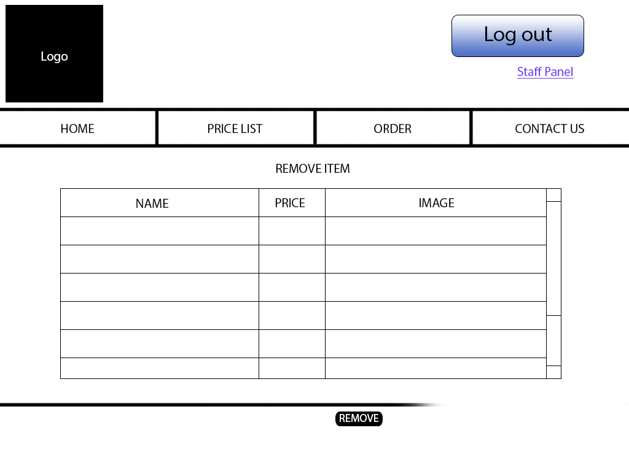
The member of staff can access this page only from the staff panel.
From here they can remove items by clicking on the item row so it’s highlighted, then clicking on the remove button.

View pending orders page

Non-business customers
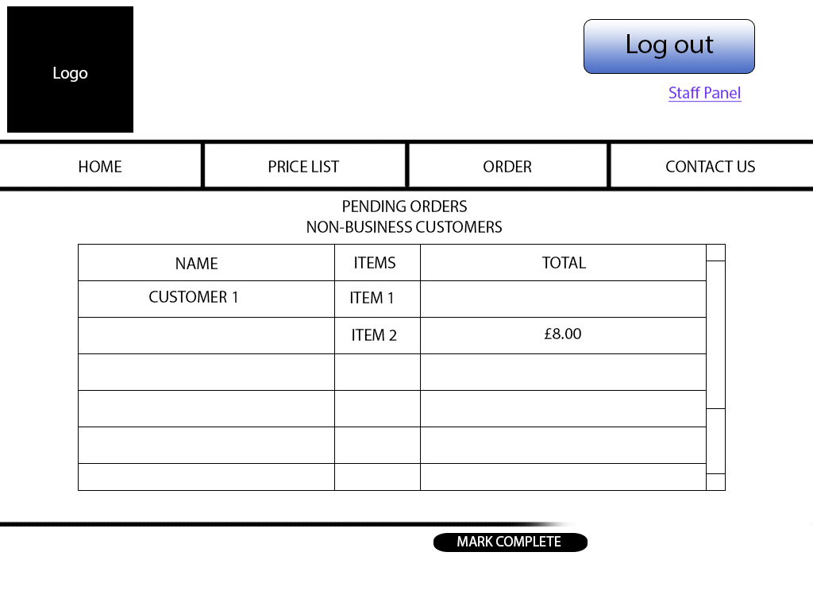
The member of staff can only access this page from the staff panel. Here they can view pending orders, and mark them as complete.

Business customers
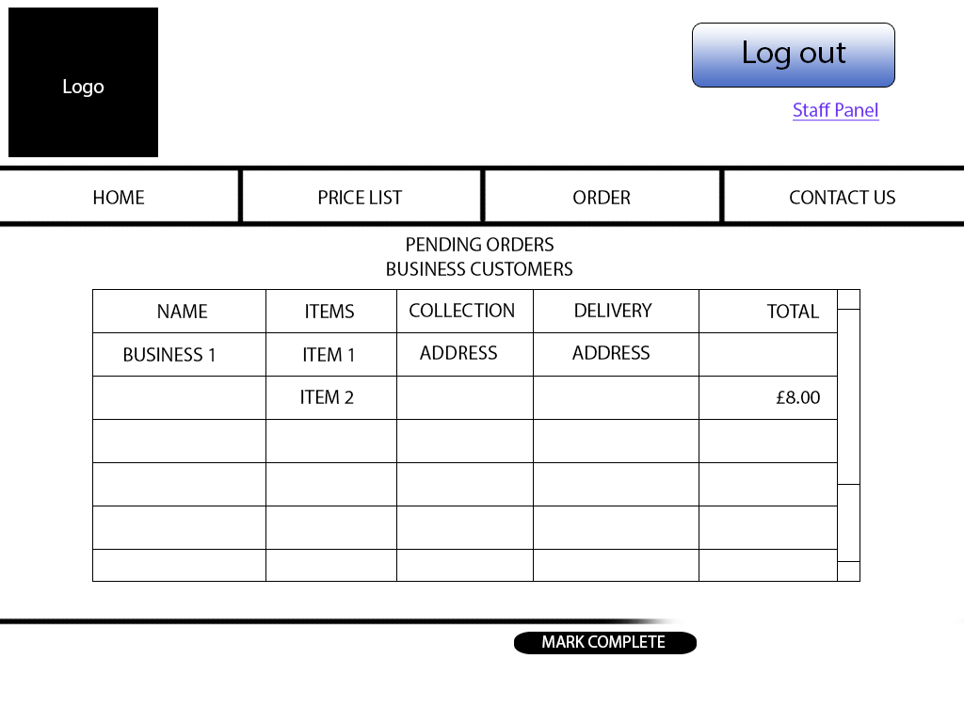
The member of staff can only access this page from the staff panel. Here they can view pending orders, and mark them as complete.

View complete orders page

Non-business customers
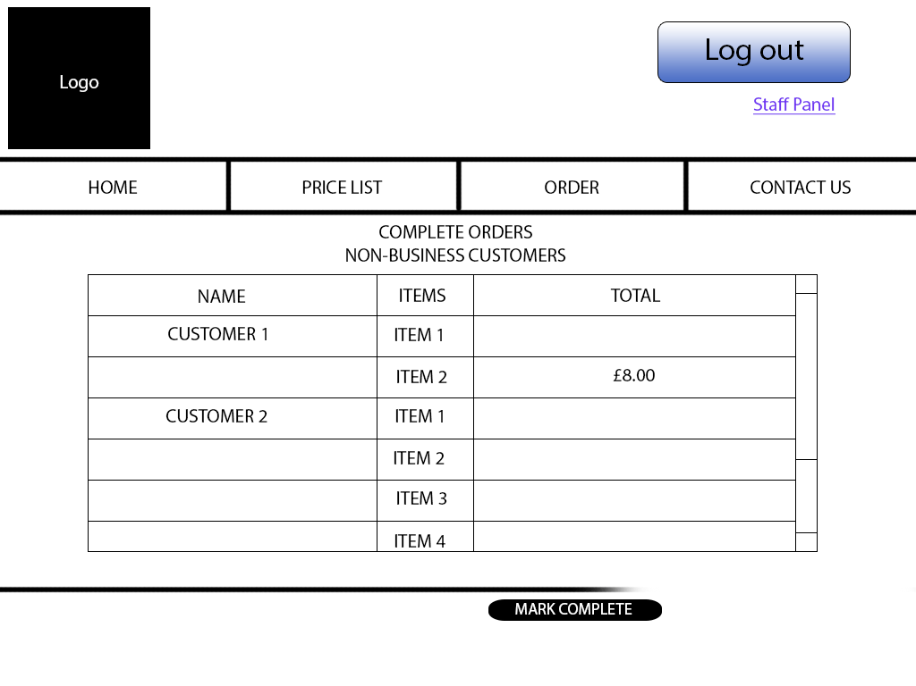
The member of staff can only access this page from the staff panel. Here they can view all previous orders from non-business customers.

Business customers
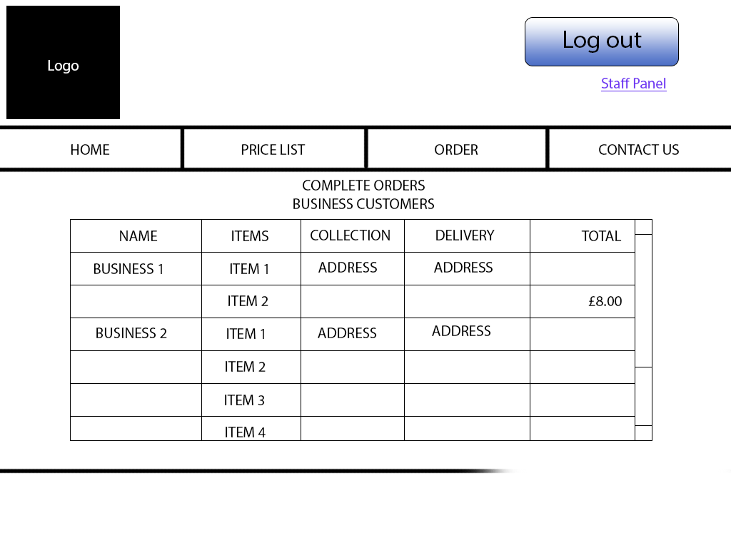
The member of staff can only access this page from the staff panel. Here they can view all previous orders from business customers.

Create staff account page
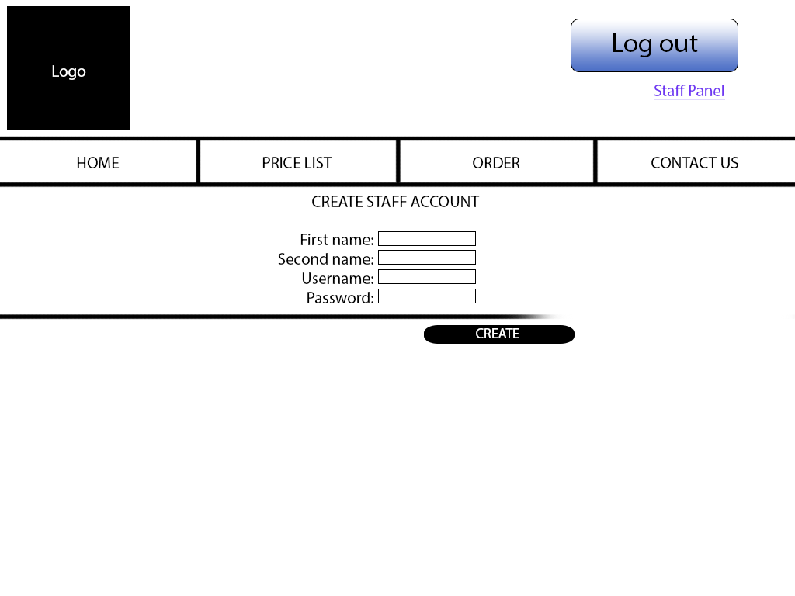
The member of staff can only access this page from the staff panel. Here they can create staff accounts.

